**General:**

The largest number of hospital visitors have non-life-threatening physical injuries. The seriousness of issues prompting people to visit hospital departments is mostly assessed as moderate.

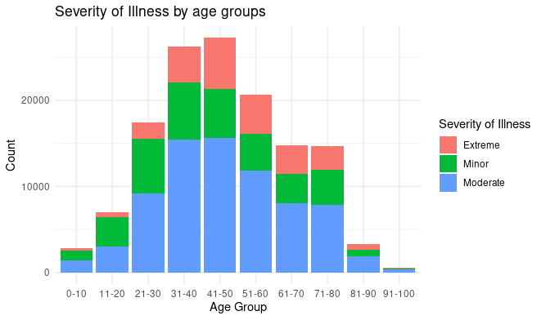

Specifics:

The most visited department is Gynecology, while the least visited is Surgery.

The age groups most frequently utilizing the gynecology department fall between 31 and 60 years old, accounting for approximately 60% of all department visitors (Group A).

The age groups most frequently utilizing the surgery department fall between 31 and 50 years old, as well as between 71 and 80 years old, constituting approximately 50% of all department visitors (Group B).

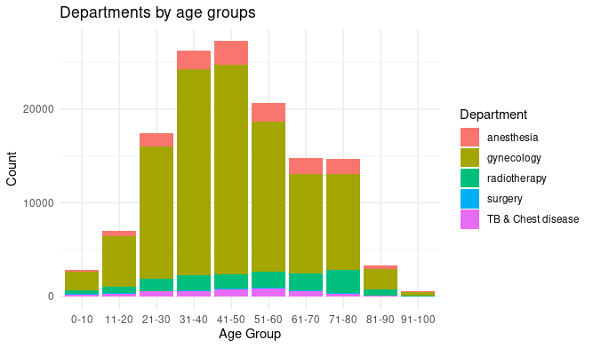

**Conclusion:**

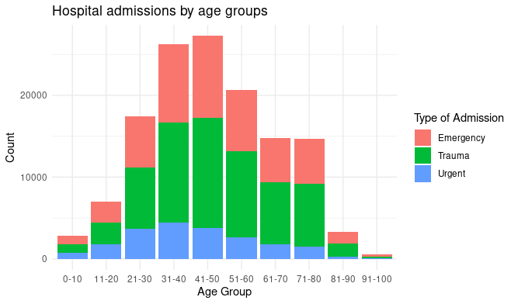

The probable cause behind this statistics is the psychology and biology of individuals. While individuals under 18 may be in the most unstable state due to adolescence, their bodies tend to recover from many traumas and illnesses more successfully compared to those who have entered adulthood. Therefore, adults often sustain injuries due to their own activities and accidents.

Gynecology: The probable reasons for these statistics may not only be age-related exacerbations of urogenital system issues but also the outcomes of unprotected sexual contacts.

Surgery: Moreover, an individual's hypothetical habitat area significantly expands with age, leading to a continuous possibility of injury-inducing situations for any biological being.